Determine Your Subsystems
In this activity, you will define the subsystems that make up your system. If you do not have a system design in mind to work with for this project, you may choose to start with a Toy Design ScenarioLinks to an external site. that is provided as a starting point.
Task: Determine Your Subsystems
Instructions:
Divide the system design responsibilities into various subsystems.
Some of the ways to help you determine these subsystems can be:
- functionality
- skill sets within your team
- company organizational structure
You can also use any combination of these approaches. Keep in mind that identifying subsystems can be an iterative process. Make your best guess, and be ready to adjust if your subsystem definition doesn't seem to be working for you.

This is Complete When...
You have defined all the subsystems that make up your system.

You can assign your subsystem teams by functionality, such as power, sensors, and housing subsystems.
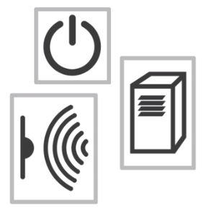
Or you can assign your subsystem teams by groupings of expertise, such as electrical, mechanical, and software subsystems.
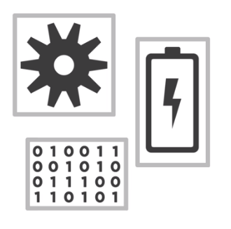
Or you can assign your subsystem teams by the organizational structure of your company, such as a communication group, a structural group, and a user interface group.
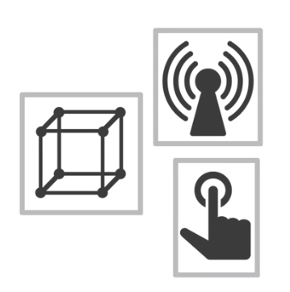
Or you can devise basically a mix of these approaches.
One of the keys is to make sure that your subsystems are not defined by attributes or performance criteria, such as speed or safety. These are things that subsystems are concerned about, not subsystems themselves.
The important thing is that you have some sense of what each subsystem's responsibility is. However, you come up with those assignments is really up to you. Just make sure you understand the responsibility of each subsystem.

